

Table of contents

**Table of contents** - 1 -

A. **Before you start** - 2 -

1. Gcode preparation: - 2 -

2. Materials - 6 -

a. PCB board: - 6 -

b. Painting: - 6 -

c. Boards painting: - 7 -

d. Wooden Socket: - 7 -

3. Focus setup - 8 -

B. **Single Circuit Marking** - 13 -

1. Material mounting - 13 -

2. Code input and control: - 15 -

a. Gcode: speeds - 15 -

b. Gcode: hatching distance - 18 -

c. Luban: laser power, fan, run boundary and door detection - 19 -

d. Material thickness and Start - 23 -

3. Marking - 25 -

4. Job End - 26 -

C. **Multiple Circuit Marking** - 27 -

1. Gcode nesting - 27 -

2. Material mounting - 28 -

3. Code input and control - 28 -

4. Marking - 28 -

5. Job End - 28 -

D. **Troubleshooting** - 29 -

Luban Version 4.1.3

# **Before you start**

## Gcode preparation:

|  |  |  |
| --- | --- | --- |
|  | 1 | If you open Luban for the first time, make sure you have selected the right machine (Snapmaker 2.0 A250) |
|  |  |  |
|  |  |  |
|  | 2 | Go to “*Get Started*” section of Luban, and select “*Laser*” |
|  |  |  |
|  |  |  |
|  | 3 | Select “*3-axis*” in the laser menu |
|  |  |  |
|  |  |  |
|  |  |  |
|  |  |  |
|  | 4 | In the window just opened, make sure that the settings of the design space are the same as those shown in the figure |
|  |  |  |
|  |  |  |
|  | 5 | Select the “*Open*” button |
|  |  |  |
|  |  |  |
|  | 6 | Now select the DFX file you want to import in Luban. |
|  |  |  |
|  |  |  |
|  |  |  |
|  |  |  |
|  |  |  |
|  |  |  |
|  |  |  |
|  |  |  |
|  | 7 | Select the “*Text*” button |
|  |  |  |
|  |  |  |
|  | 8 | Now add the text. Select olso its font, dimension and position  **Don’t change size of the circuit!** |
|  |  |  |
|  |  |  |
|  | 9 | While keeping selected the text box and the circuit, select “*Process*”, and then “*Create Toolpath*” |
|  |  |  |
|  |  |  |
|  |  |  |
|  |  |  |
|  |  |  |
|  |  |  |
|  |  |  |
|  |  |  |
|  | 10 | **Jog Speed** should be as high as possible while numerical values of **Work Speed**, **Number of Passes**, **Z Step** and **Laser Power** come from Matlab simulations  **Method must be “On the Path”!** |
|  |  |  |
|  |  |  |
|  | 11 | Select “*Generate G-Code and Preview*” |
|  |  |  |
|  |  |  |
|  | 12 | In the Preview window you can see the final result. If it is correct select “*export*” and then “*Export G-Code to file*” to save the the final G-Code. |

## Materials

### PCB board:

The boards have the following characteristics:

* Core material: FR4
* Single or dual sided copper clad
* Dimension: 100 x 70 x 1.5 mm

### Painting:

The following colors are allowed:

1. Black
2. White
3. Red
4. Blue

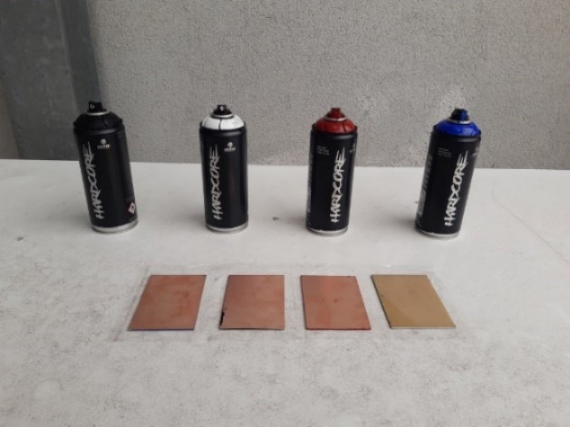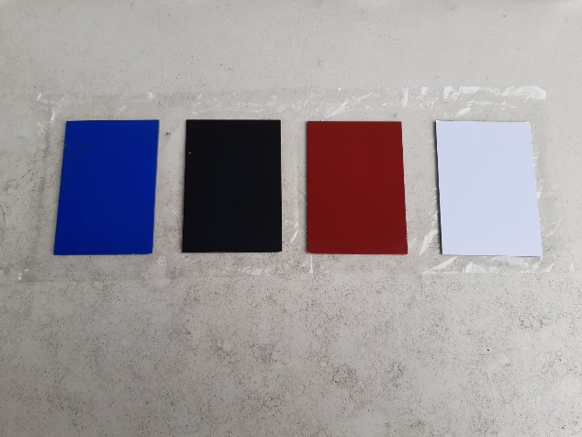

Tip: avoid using oil-based painting since it will worse laser stripping process.

During the painting job, keep in mind the following tips:

* Clean copper surface before painting
* Make sure to distribute paint equally
* Avoid touching board surface with hands if the paint is not dry
* Let the board dry for at least 2 hours before machining

|  |  |
| --- | --- |
|  |  |
| **NO** | **YES** | |

### Wooden Socket:

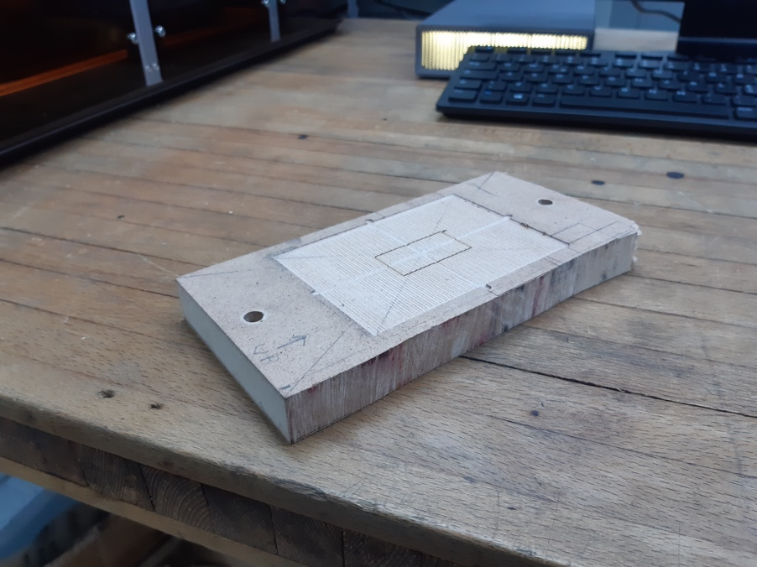

The use of the socket is not strictly necessary, but facilitates the carrying out of multiple operations. Its use will be described in detail in the paragraph “Material mounting”.

## Focus setup

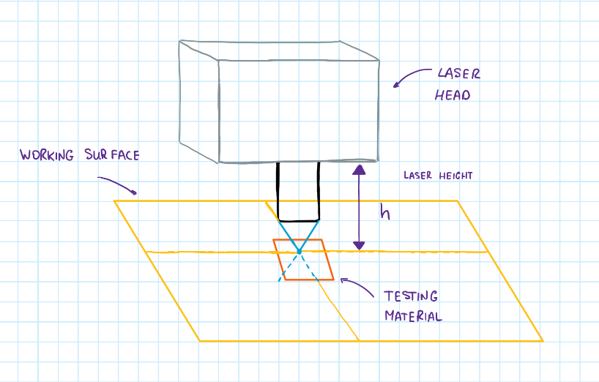Focal point is the point where laser concentration is maximum. It is calculated from the testing material surface (see the picture). We should set it properly in order to take the most out of laser power. *H* is the value that we are about to find with the following procedure:

|  |  |  |
| --- | --- | --- |
|  | 1 | Follow the Snapmaker Quick Start Guide in order to mount the laser head, **with the wood working area**. |
|  |  |  |
|  |  |  |
|  | 2 | Turn on the machine, and enter the “Settings” menu. |
|  |  |  |
|  |  |  |
|  | 3 | Select “Laser” menu. |
|  |  |  |
|  |  |  |
|  | 4 | Make sure the “Auto Focus” procedure’s flag is set to Off. |
|  |  |  |
|  |  |  |
|  | 5 | Follow the Snapmaker Quick Start Guide in order to set the laser focus manually. |
|  |  |  |
|  |  |  |
|  | 6 | In the same menu of point 3, select “Adjust Laser Height”. |
|  |  |  |
|  |  |  |
|  | 7 | In this window you can annotate the value of the correct laser height, or if you already know it you can directly set it without doing the procedure from point number 4 to 5.  Now the laser focus is calibrated. |

# Single Circuit Marking

## Material mounting

|  |  |  |
| --- | --- | --- |
|  | 1 | Follow the Snapmaker Quick Start Guide in order to mount the laser head, with the wood working area. |
|  |  |  |
|  |  |  |
|  | 2 | Fix the Wooden Socket to the working surface, using two M4x30 screws. Make sure the UP arrow pointing outwards form you.  **If you use screws longer than 30 mm, make sure that the working area and the laser head move freely.** |
|  |  |  |
|  |  |  |
|  | 3 | Set the laser power to 5% and find the point where diagonals of PCB board cross. Remember the X and Y coordinates of the laser in this position |
|  |  | Create Marco command using coordinates found in precedent step  Keep in mind to execute this command and click Set work origin each time you execute round boundary or Start on Luban. |
|  |  |  |
|  | 3 | Inserimento della board al interno della tasca. |

## Code input and control:

After we have exported our gcode it is time to make final check before launching the process.

### Gcode: speeds

Click on the exported gcode with the right button of the mouse and chose “Open with”.

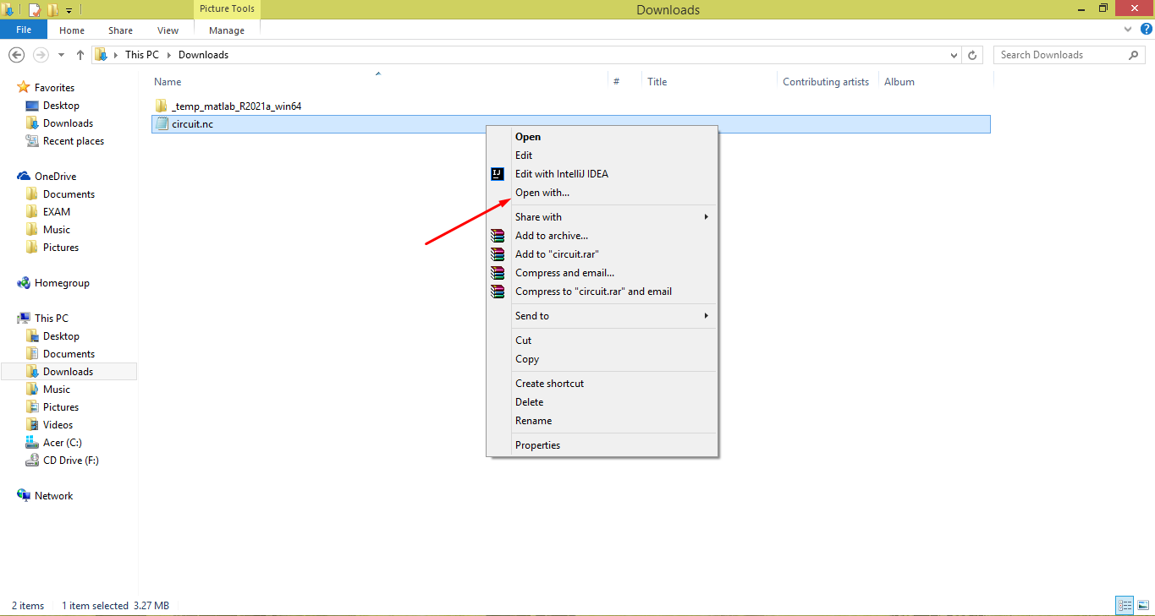

Select Notepad or any other text editor that you usually use

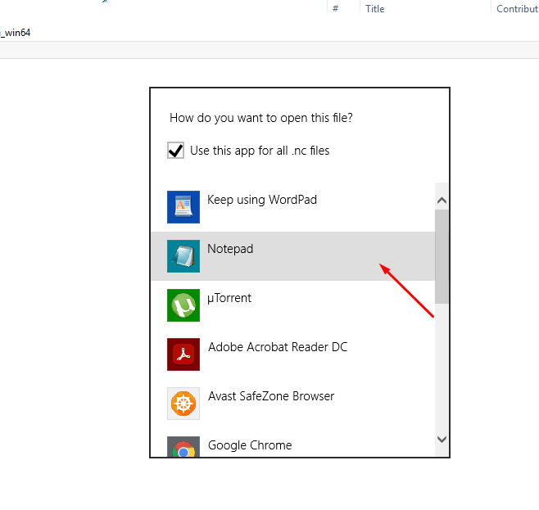

Now you should see the set of instructions that machine will execute in order to print your circuit

We will control couple of them.

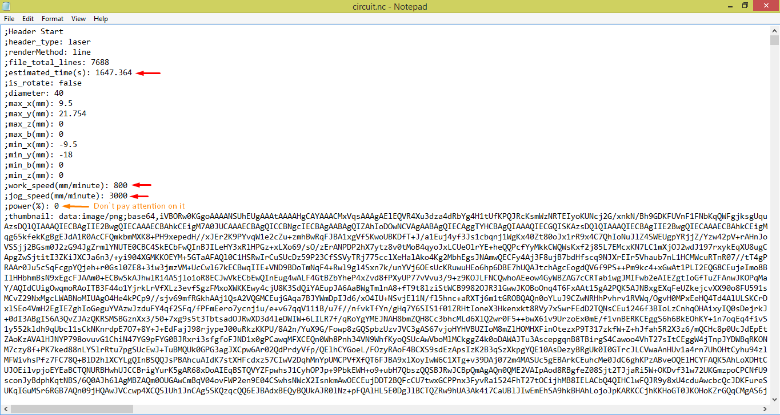

You can see how much time ( in seconds ) marking take in ”estimated_time(s)” row.

You can also see the work_speed ( speed of the laser head while it strips ) and jog_speed ( speed of the laser head while it is not stripping ).

Don`t pay attention on the power row since it will be overwritten inside luban

Scroll down until appears the first row without semicolon ;

1. Jog Speed & Work Speed

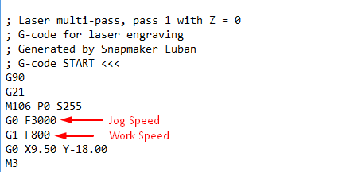

Make sure Jog Speed & Work Speed are correct and if not you have 2 options

1. **Safe Option:** Create new gcode from the start ( from .dwg file )
2. **Risky Option:** Manually rewriting those commands for each pass of your circuit

Click Ctrl + F and type in “Header Start”, choose Direction: Down and click “Find Next”

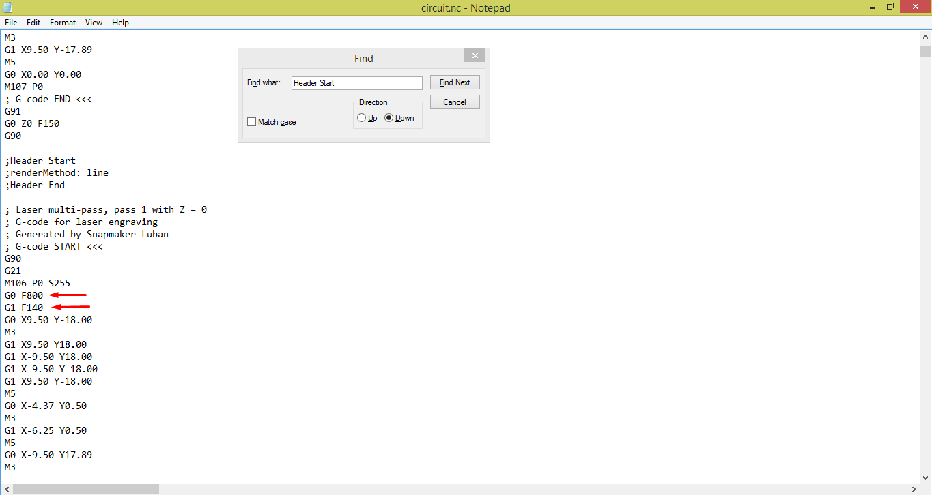

This way you will iterate through each pass of your circuit and you should pay attention to correct G0 F ( Jog Speed ) and G1 F ( Work Speed ) in each pass.

Just manually change the number inside the row

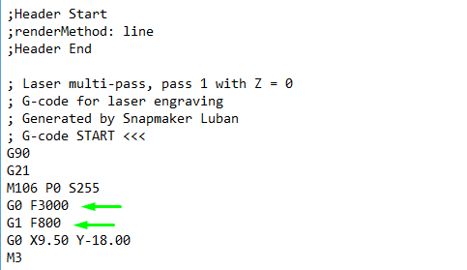

Corrected

### Gcode: hatching distance

It is enough to control hatching distance of the first pass

Find the first row without semicolon ; and look at the code after it

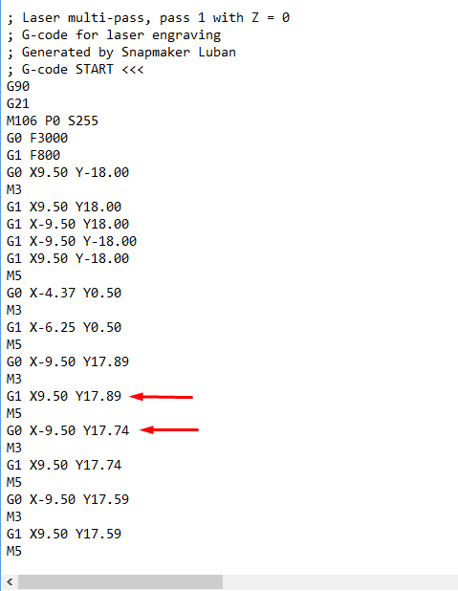

Find some 2 rows with G1 and decreasing Y coordinates.

The difference between Y coordinates is hatching distance

In our example H = 17.89mm - 17.74mm = 0.15mm

Make sure Hatching distance is correct and if not you have only 1 option:

**Control hatching of your .dxf file in Autocad and create new gcode from the start**

### Luban: laser power, fan, run boundary and door detection

Open Laser -> 3-axis

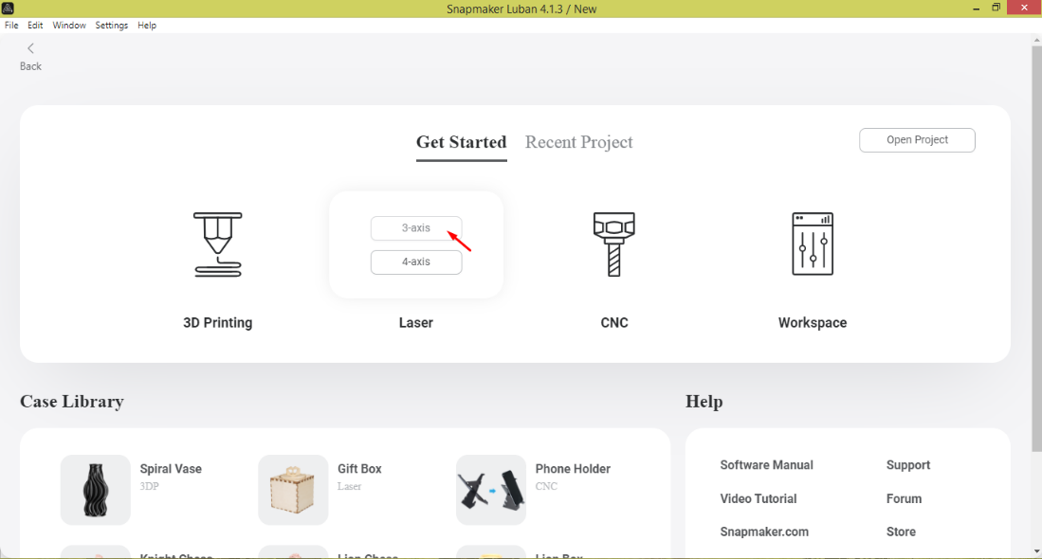

Verify work size and click confirm

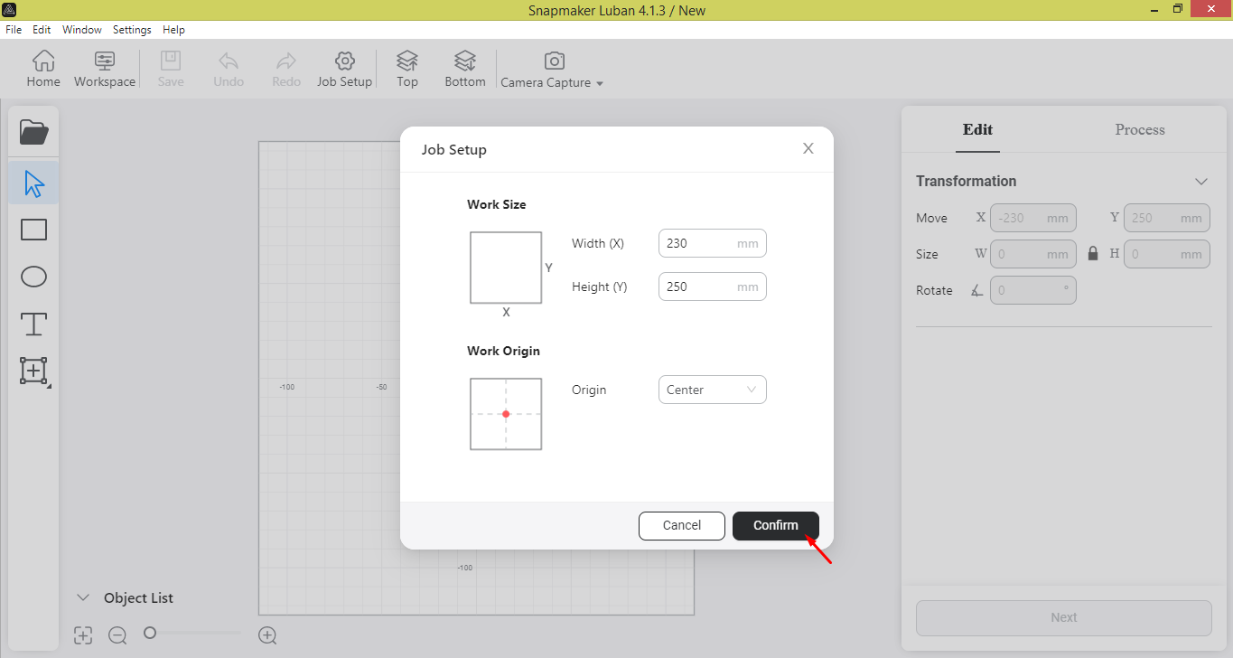

Go to workspace

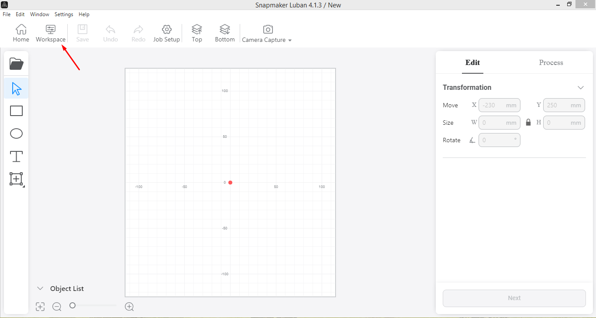

Choose Snapmaker device ( It must be connected to the same wi-fi network )

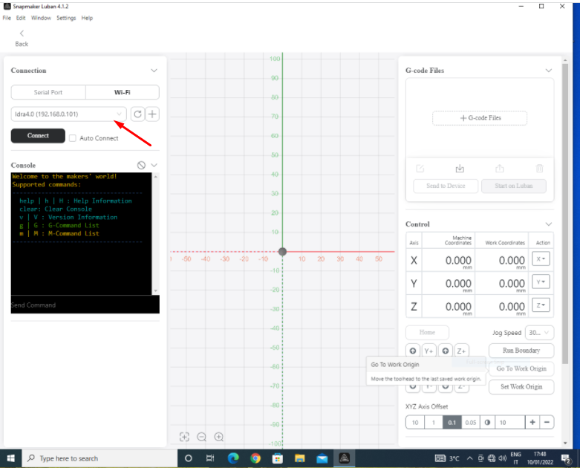

Click + G-code files and open the gcode that you have prepared ( make sure it has .nc extension )

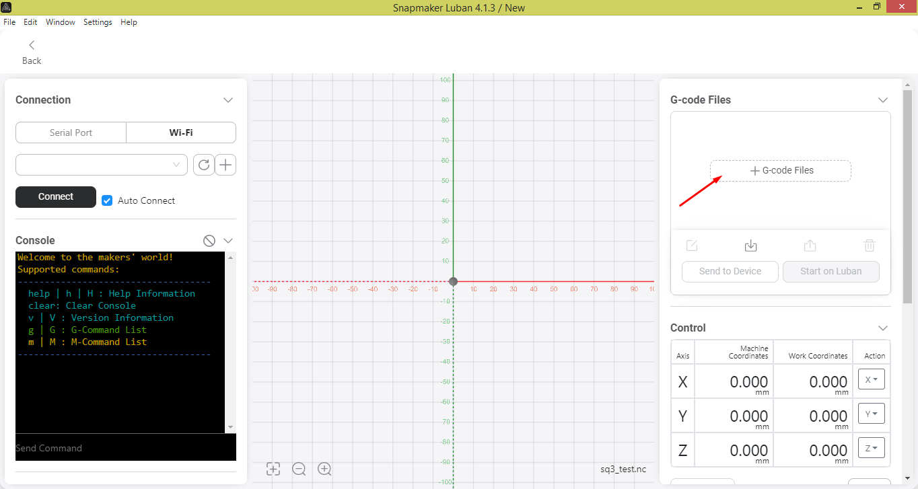

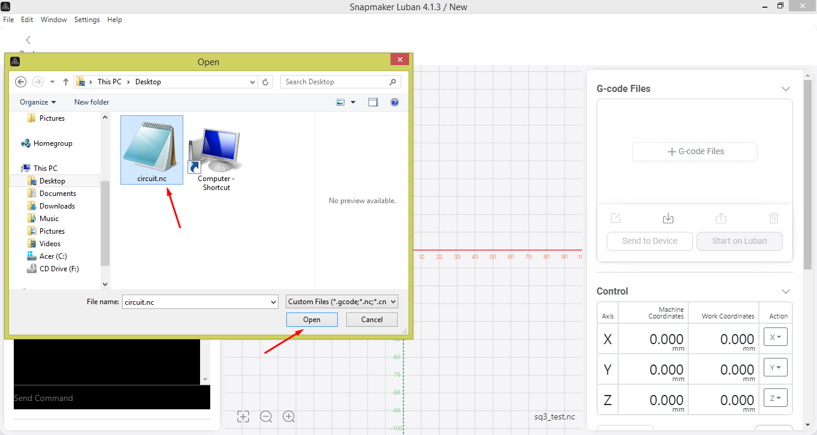

Control that LED Strips, Exhaust Fan and Door Detection are always on

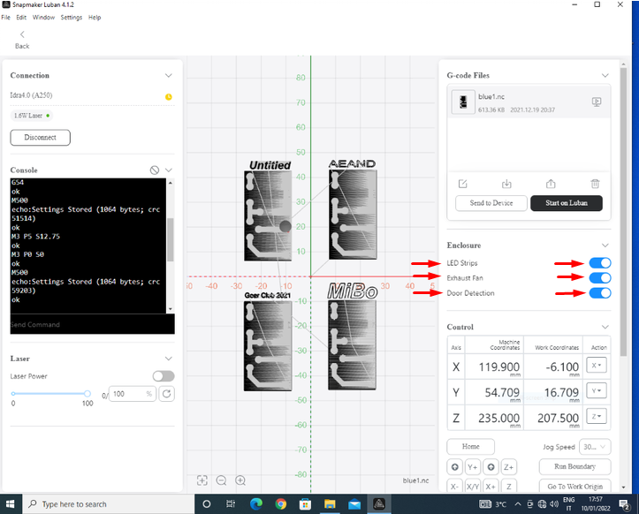

Execute macro that you created in step B.3 then click Set Work Origin and then click “Run boundary”

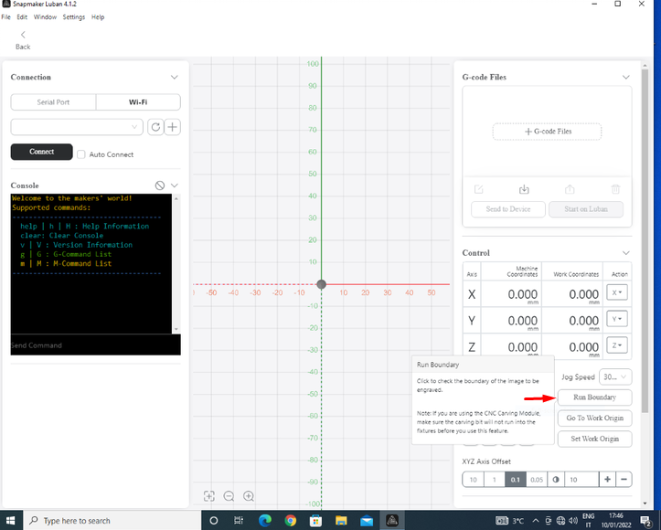

### Material thickness and Start

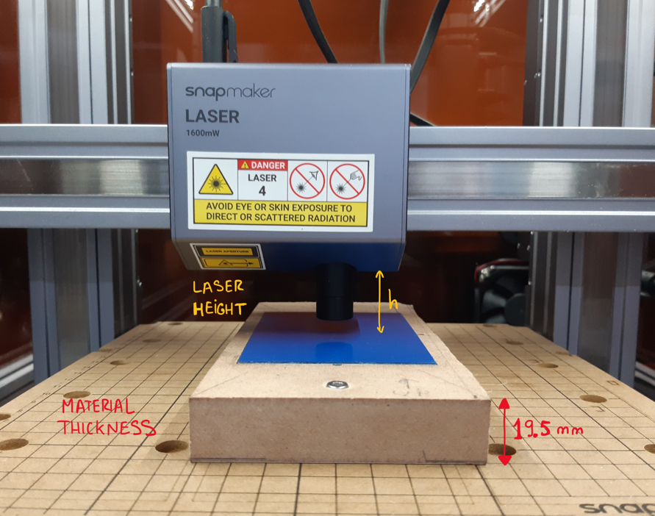

Material Thickness should be equal to the height of material that you put on the work surface (in our case it is the height of the wooden socket)

In order to set material thickness click “Start on luban”

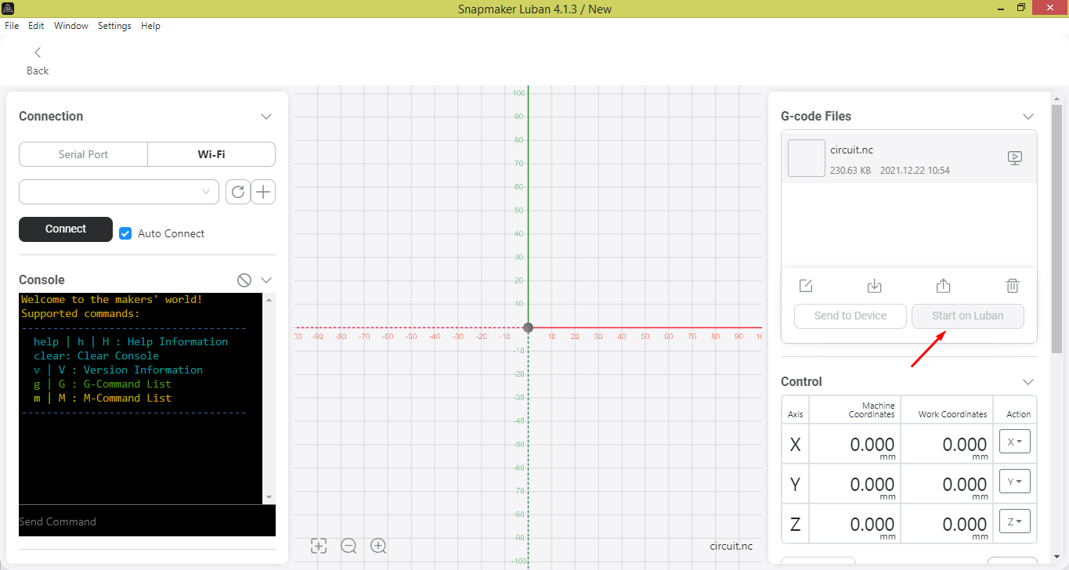

The window will pop up where you will be able to set up material thickness. Don’t forget to choose Auto Mode

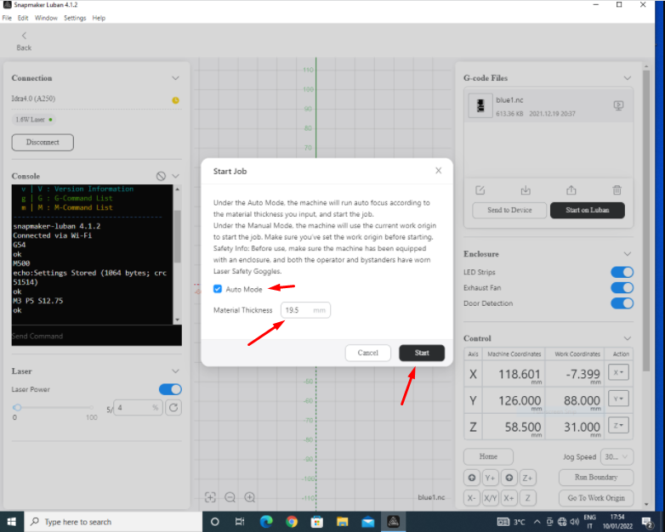

Right after that turn on Laser Power to 100 % and click arrow button

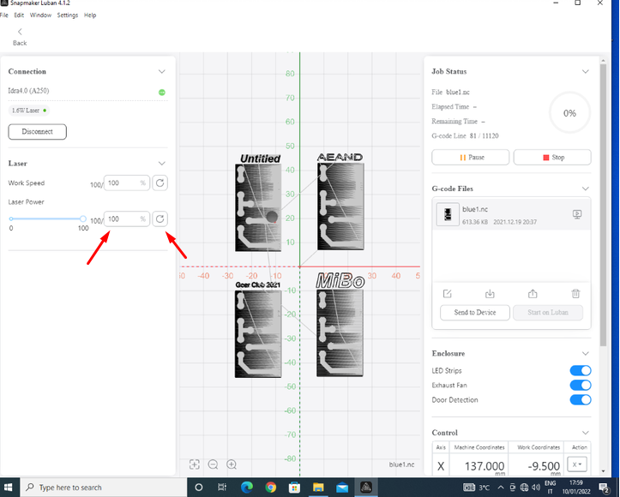

## Marking

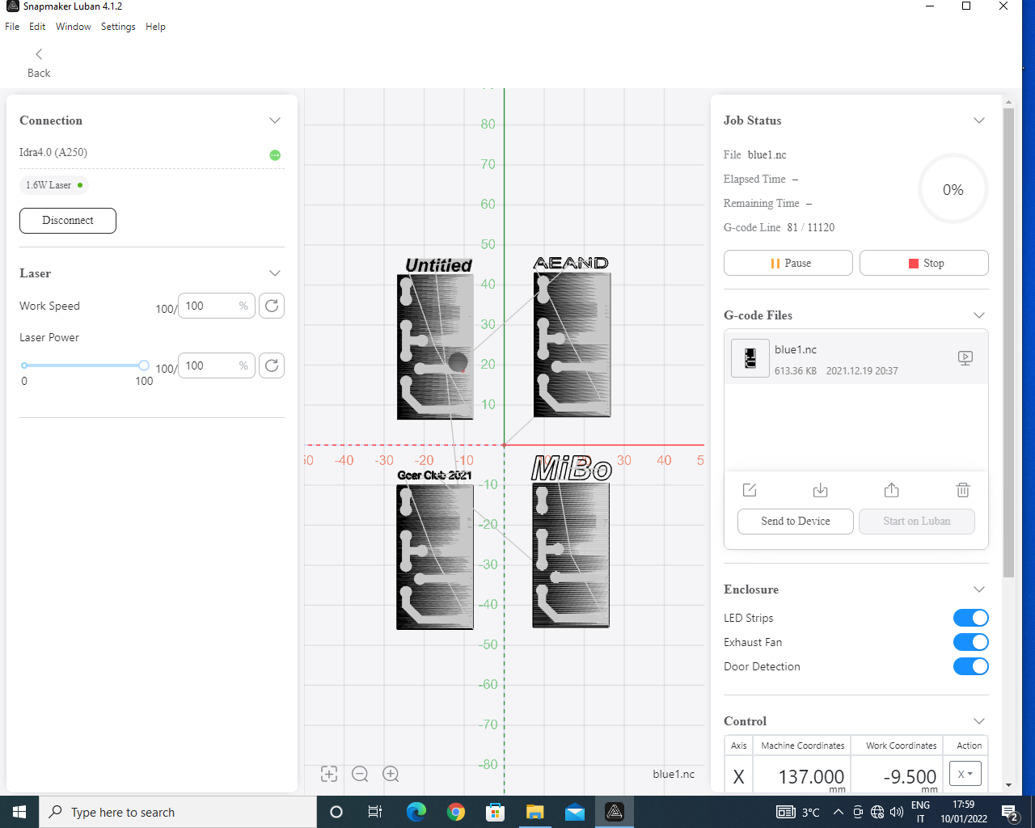

## Job End

Foto di Ale che passa la straccia + foto della machina spenta

# Multiple Circuit Marking

The purpose of this section is to illustrate how to laser stripping a board with multiple circuits, joining *n* single .nc files, in a single .nc file containing *n* circuits. To illustrate the procedure we will refer to the example of joining 4 circuits, but the method can be easily extended to cases where *n*>4.

## Gcode nesting

|  |  |  |
| --- | --- | --- |
|  | 1 | First you need to estimate where you want the circuits on the board. Then in the workspace you can imagine to place the board (orange rectangle), and the 4 circuits (purple rectangles). You can now estimate the coordinate A and B, obtaning the position of the four circuits centers in the workspace reference system:   * C1(A,B) * C2(-A,B) * C3(-A,-B) * C4(A,-B)   Where A and B are the numerical values that you estimated. |
|  |  |  |
|  |  |  |
|  | 2 | Now you can create a new .nc file, with the following structure.    We use the command G92 to shift the work origin in the center of each circuit, before starting to stripping it. After the G92 command you need to paste all the contents of the file related to the first circuit.  Before starting the next circuit, you need to shift the previous origint to the new poistion.  This procedure must be repeted for all the 4 circuits. At the end, save and close the final .nc file. |
|  |  |  |
|  |  |  |
|  | 3 | Now you can import the final .nc file in the workspace preview, and check if all the circuits are in the correct position and fits inside the board perimeter.  If not, return to the poin 2, change the A and/or B values, and check again in the workspace preview if the circuits position are correct.  Repeat this trial and error procedure until the result is correct. |

|  |  |
| --- | --- |
|  | Luban up to version 4.1.3 It is affected by an alleged bug: until the insertion of three circuits the procedure described above works fine. However, starting from the fourth circuit, the position of the centers no longer follows this logic, therefore starting from the fourth circuit it must be determined by trial and error. |

## Material mounting

Same procedure described in paragraph B.1.

## Code input and control

Same procedure described in paragraph B.2.

## Marking

Same procedure described in paragraph B.3.

## Job End

Same procedure described in paragraph B.4.

# Troubleshooting

|  |  |  |
| --- | --- | --- |
| Problem | Problem description | Possible causes and solutions |
| **The stripping is ineffective** |  | This problem can have multiple causes.   1. Verify your hatch distance   Low hatch distance should be compensated by greater N of passes   1. Make sure the laser power is 100% 2. Check the work speed   Don’t confuse work speed with the jog speed  Work speed is the speed of laser head when it strips !  High work speed affects penetration depth which may result in uneffective stripping |
| **The process is slow** |  | * Check input parameters   Control your gcode ( work speed and jog speed )   * Time of process is a quality tradeoff |
| **Macro doesn`t work** |  | * Make sure there`s no break line between G0 and X Y coordinates |